**Portfolio Website Process**

Het idee is om de website in 1 sprint af te maken. Deze sprint duurt 1 week.

Planning:

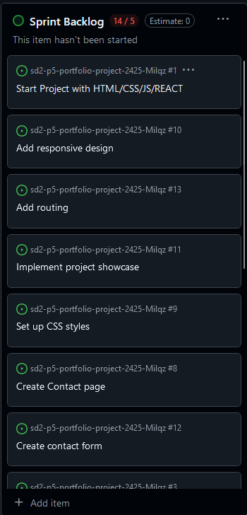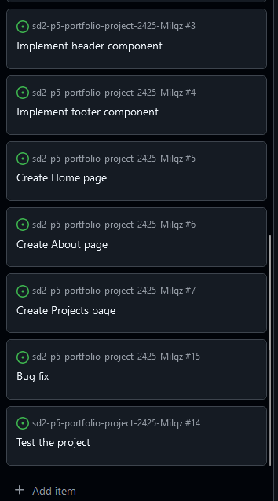

Progress:

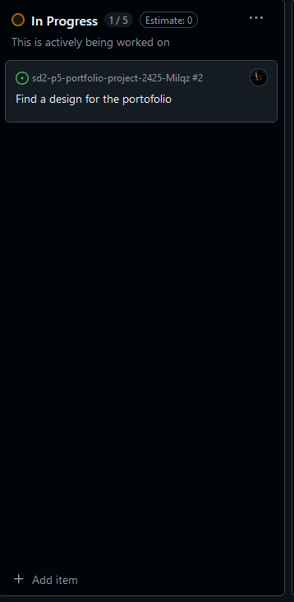

The website with the design I like:

<https://rachit.infornics.com/>

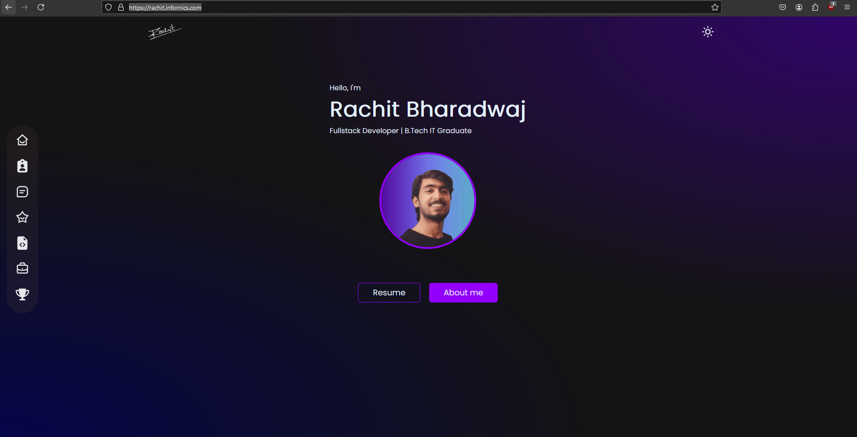

Started with the header  
  
It has a hover glow effect and it acts like a navigation bar using react.

Then I added the home page.

First design:

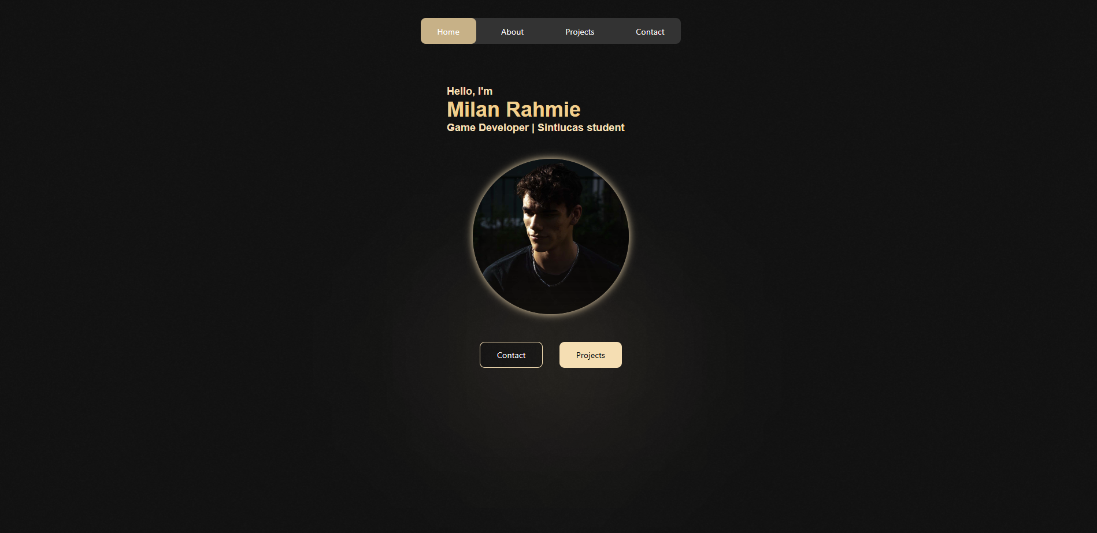

Finished version:

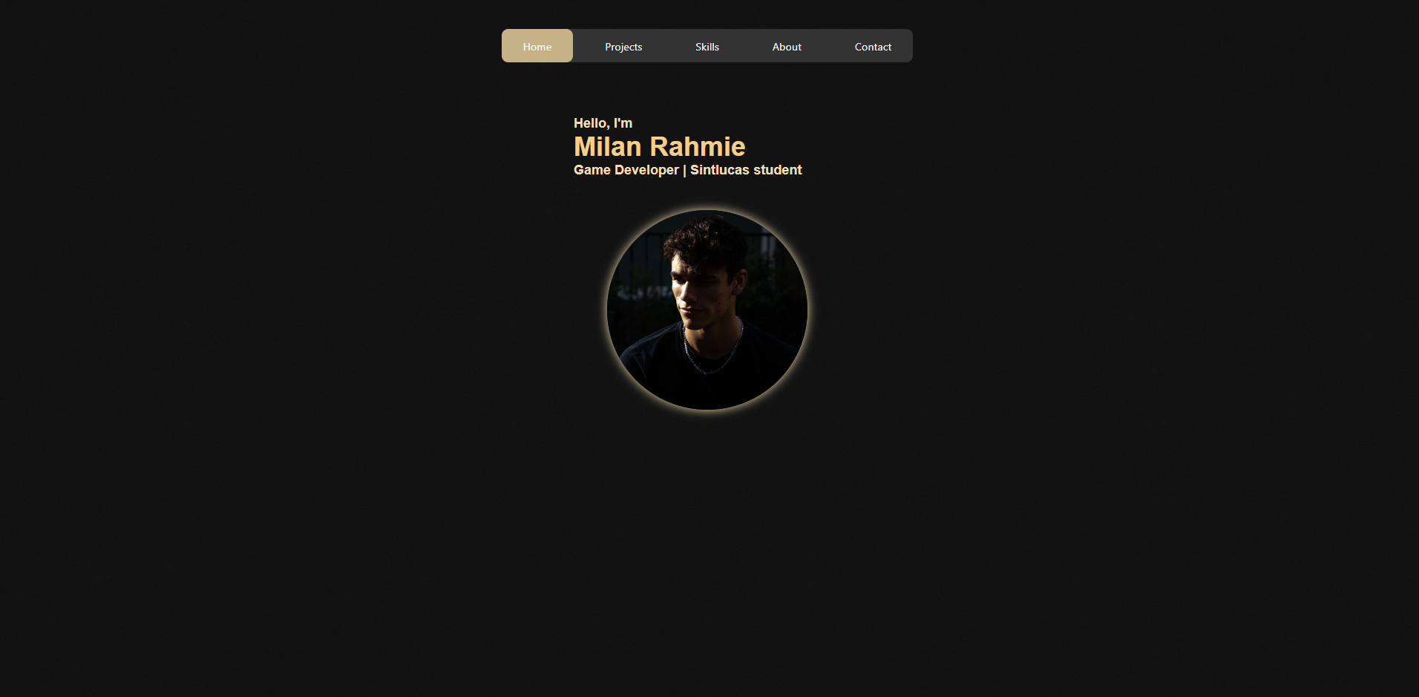

I made the choice to remove the bottom buttons because they were useless and it looked cleaner and calmer without them.  
Then I moved on to the next page, the about page.

My first design looked like this: 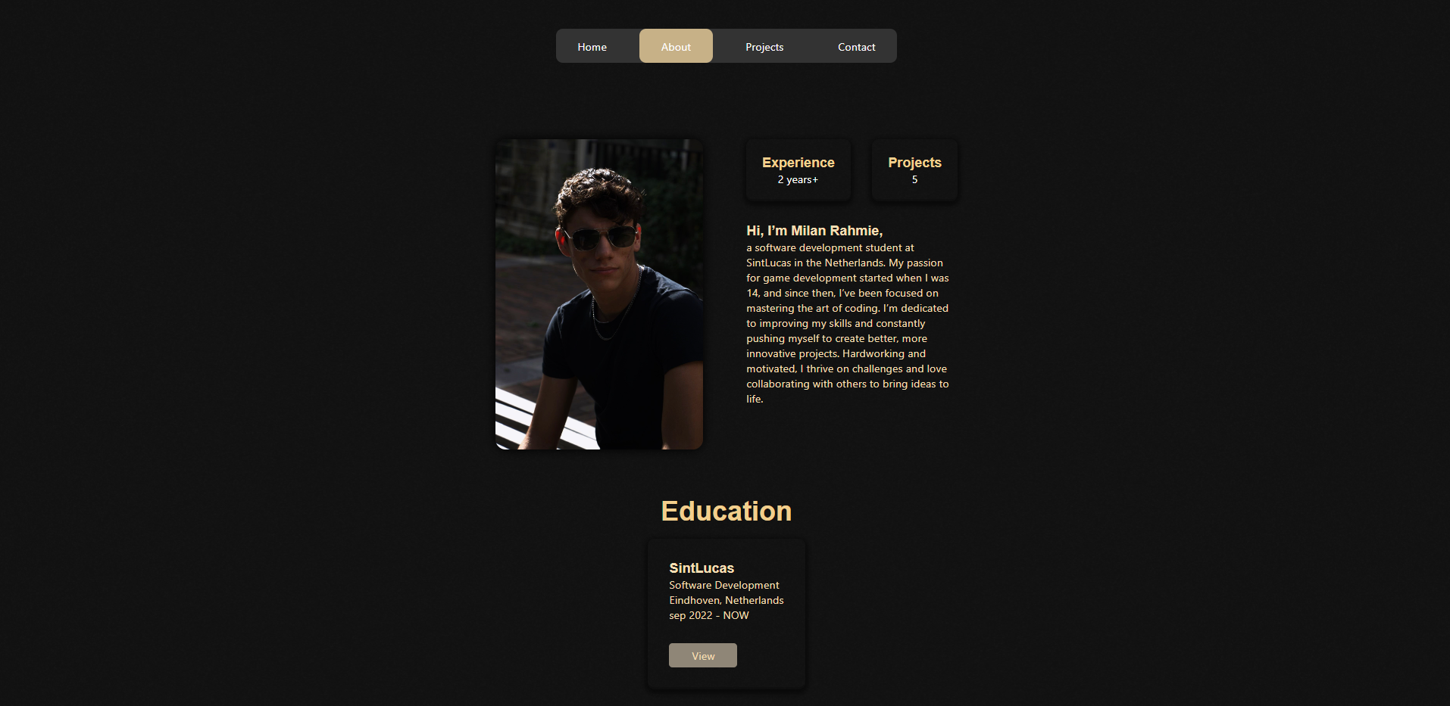

But I was not satisfied with this design at all even though I did not know what I could improve on. I ended up realizing that the education part is not necessary so I ended up removing the button and I cropped the about text and layout in width so it fits underneath the header like this:

End result:

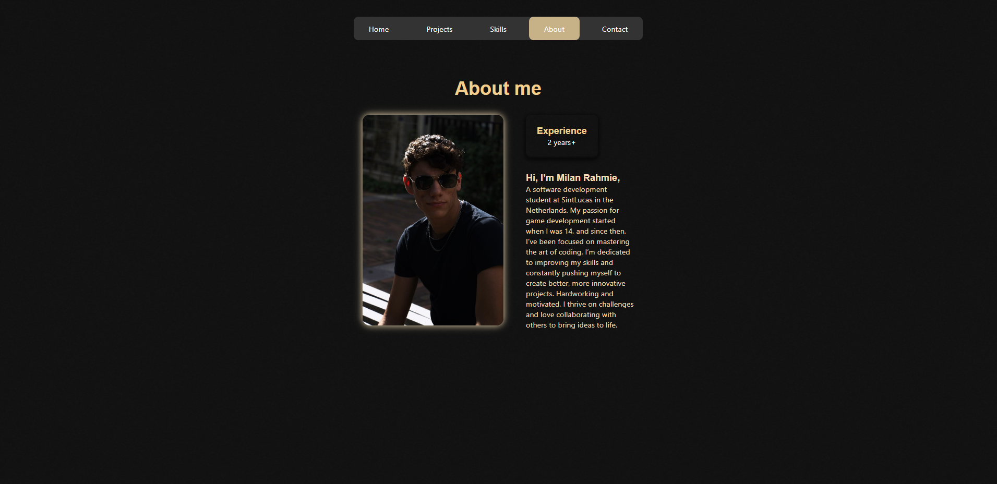

Then I made the contact page:

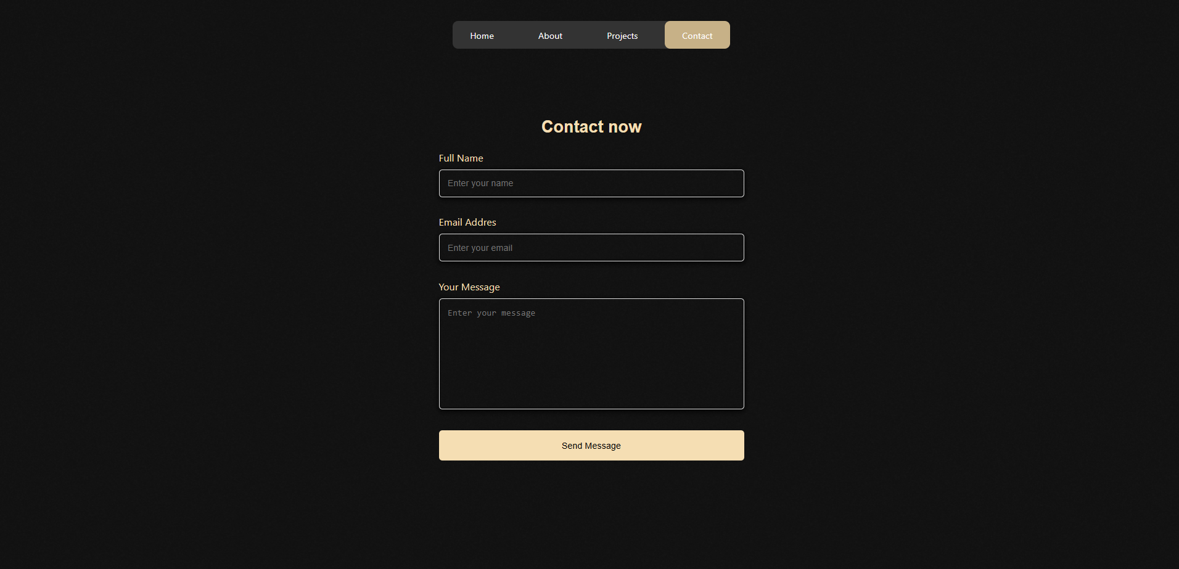  
Luckly it does work but I again wasn’t satisfied with the result so I ended up fixing it aswell:

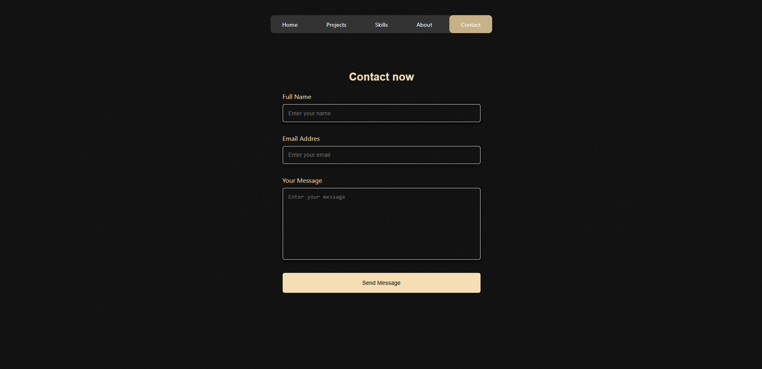

The plan here on out was to fit everything underneath the header because it felt satisfying.

I made a first design for the projects page:  
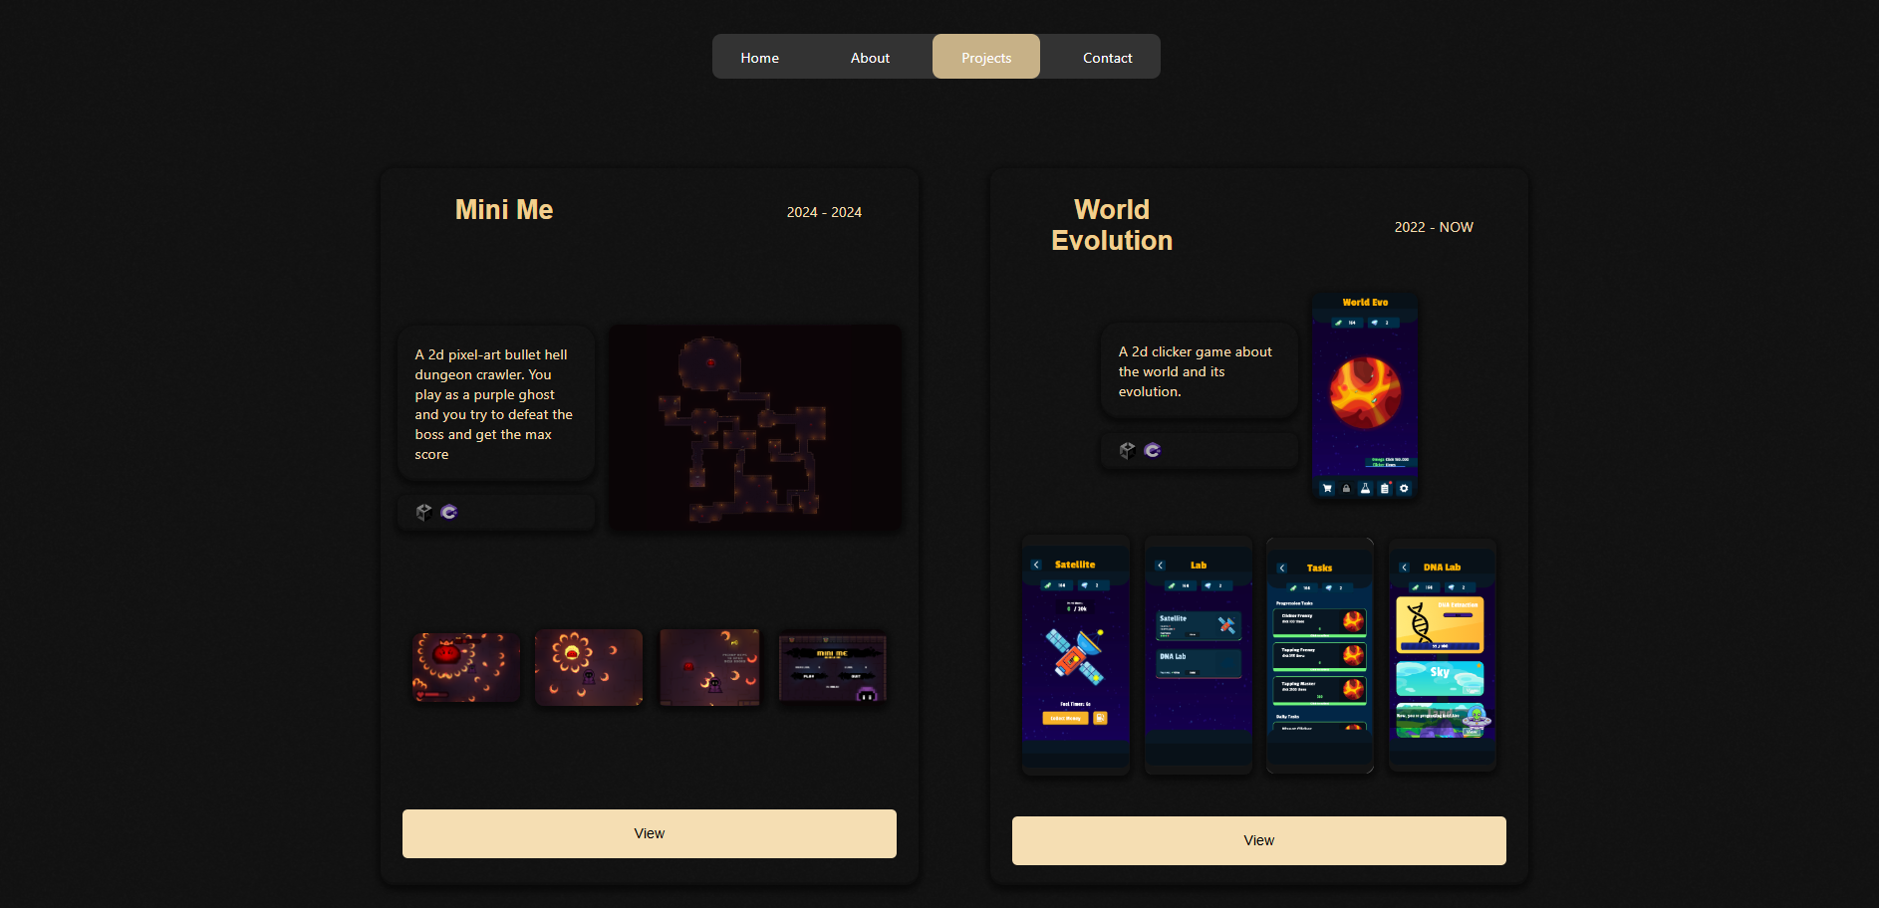

**First Lookback at the project:**

Jorrit came to me and wanted to see my website. I thought it was done but Jorrit wanted to see a project page for each single project. Because you cant see the grinds that have been put into the projects by looking at them like this. He also told me that everything that got hovered over moved and it tricked him to thinking it was a button. And I get that but on the other hand it felt super clean to have some animations. So I removed a few but kept some in there.

I ended up revamping the projects page and began by removing my old Idea.

And I made some design for the new tiles.

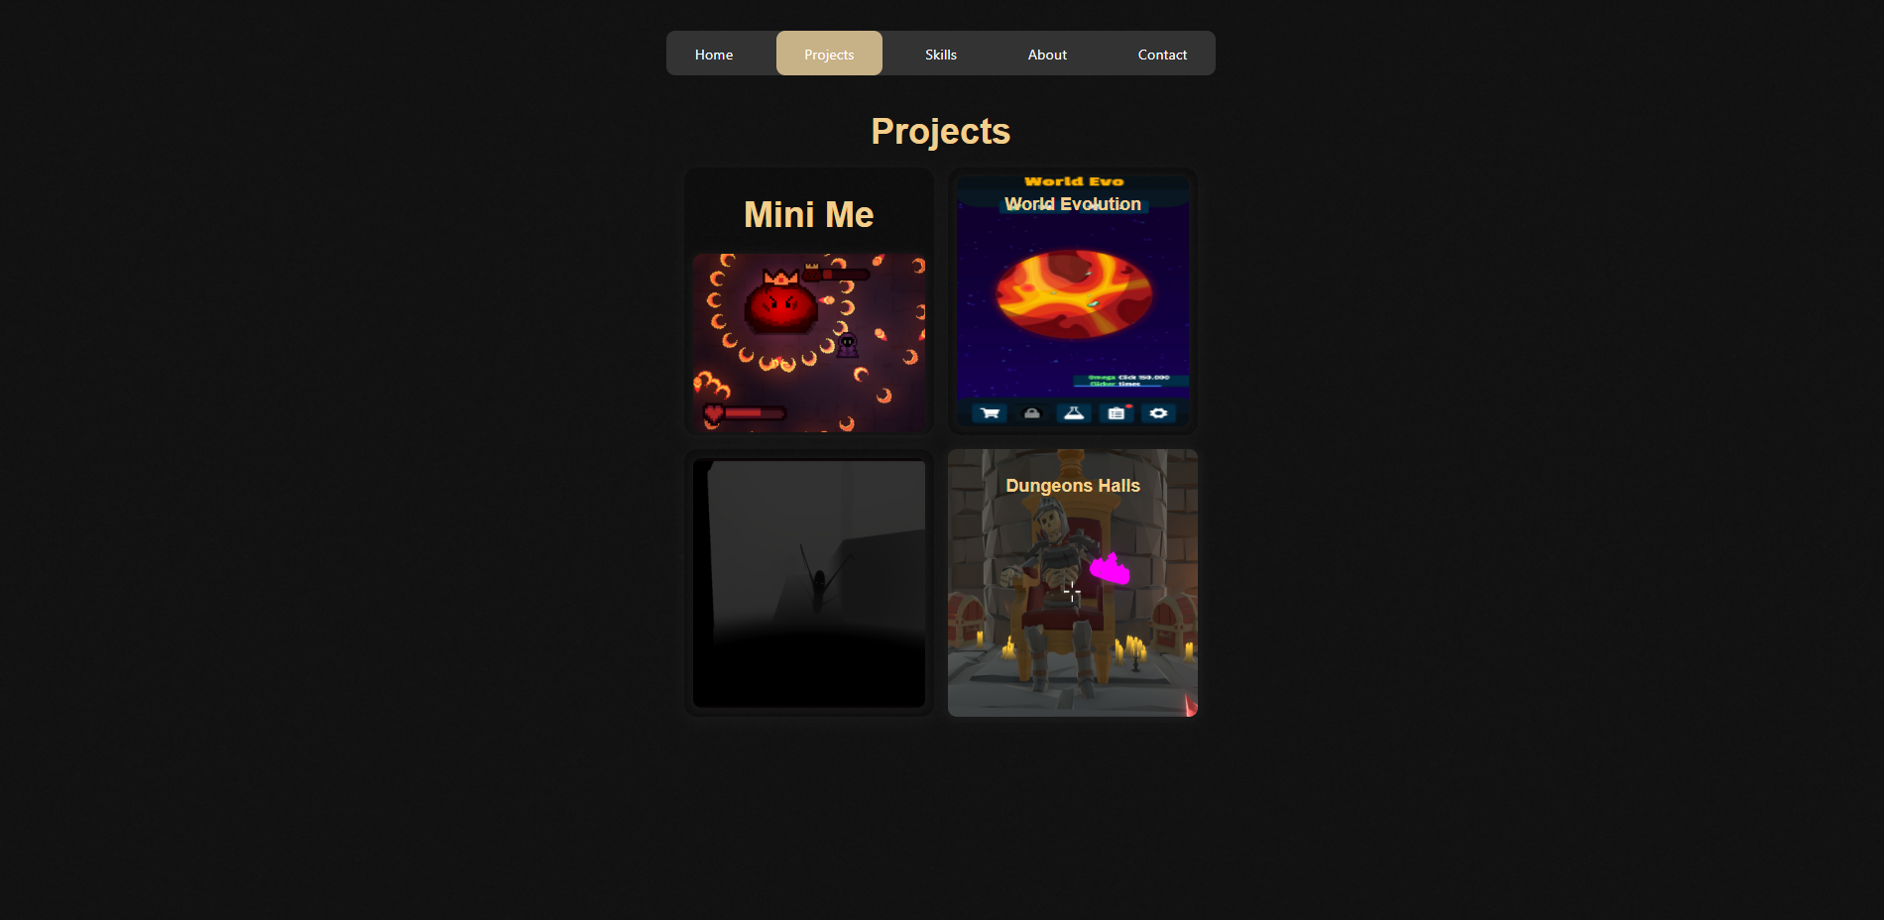

I ended up using this design with a hover effect that shows you the title and a short description:

Here you see me hovering over World Evolution

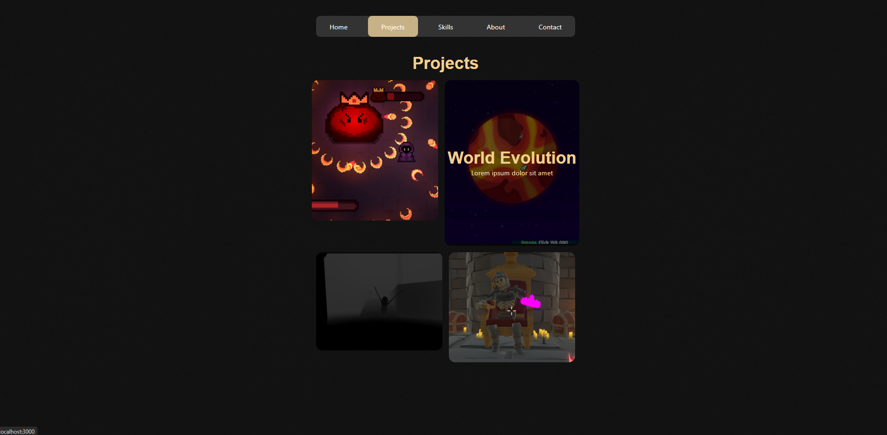

Then I fixed the layout in a cool way: 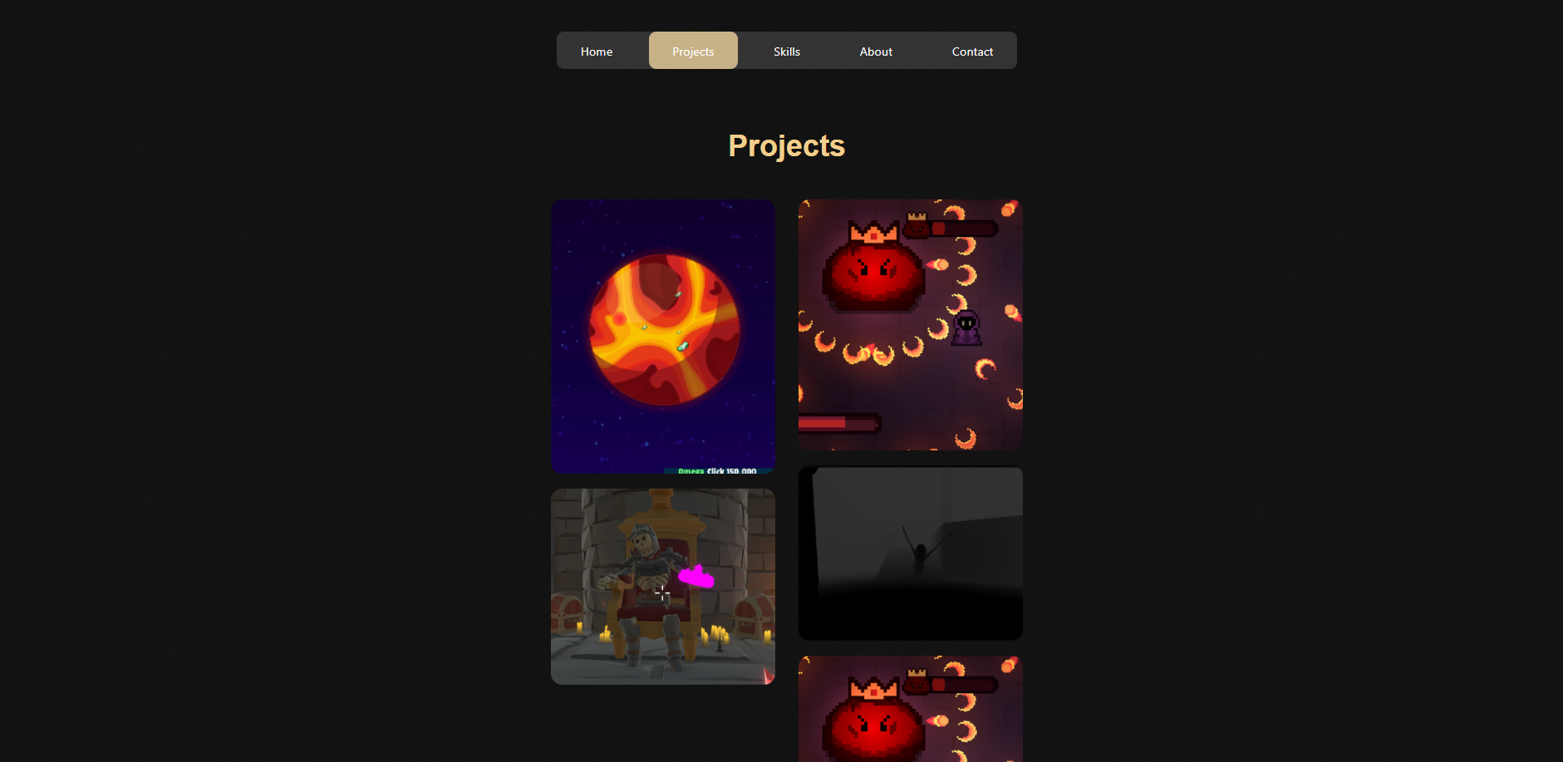

And stopped working on the projects page for now. I moved on to the last page the skills page.

First design:

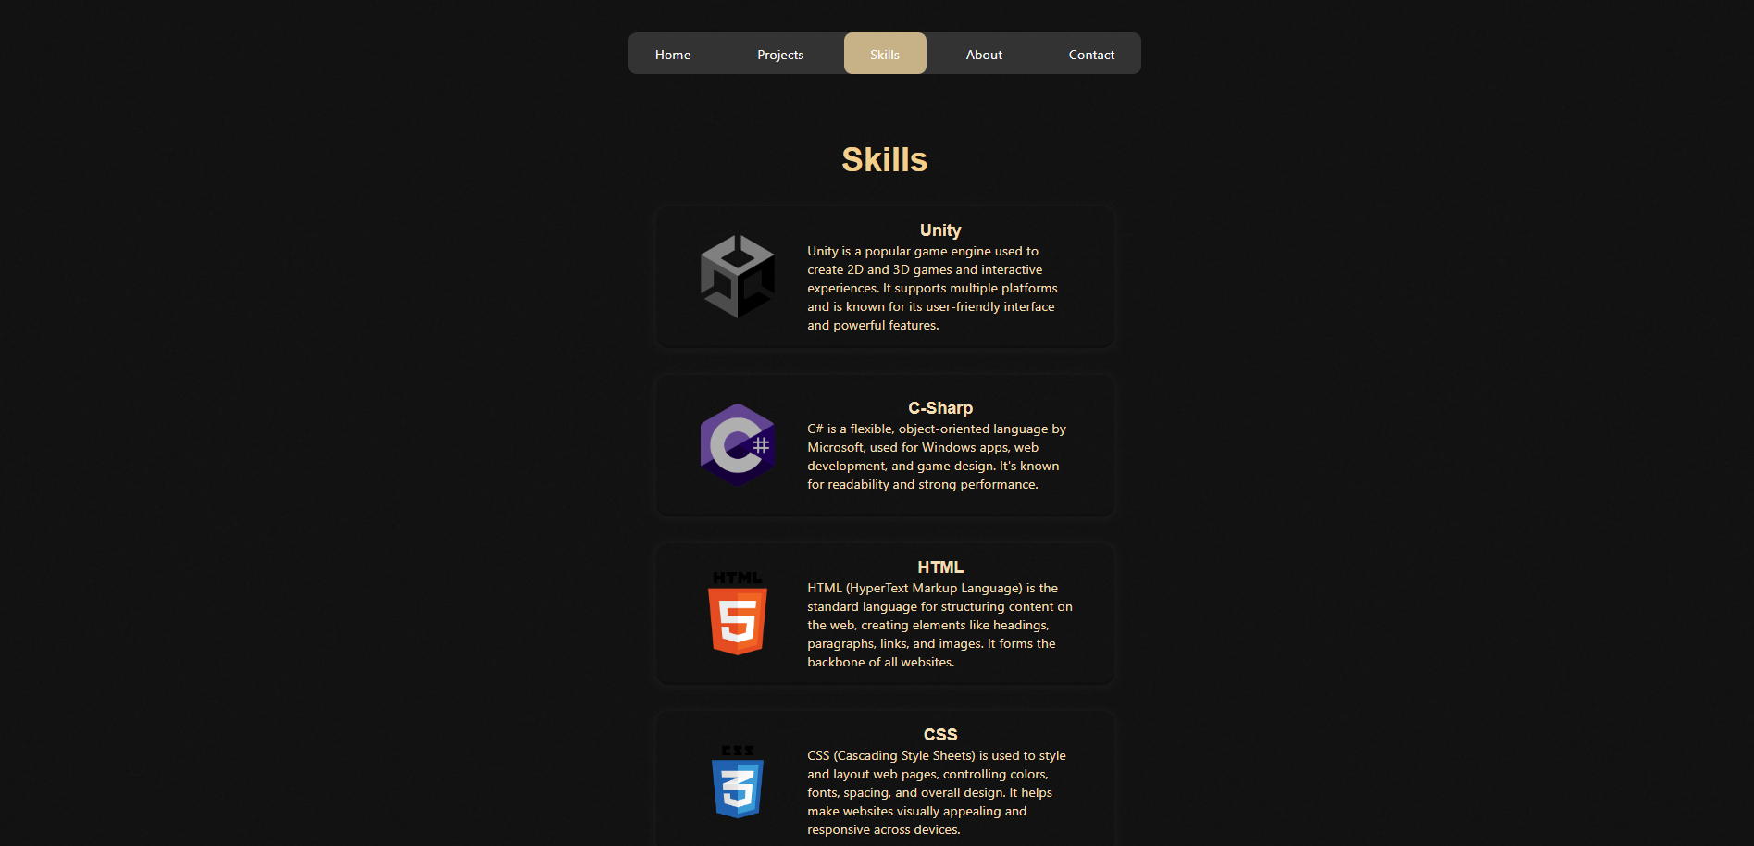

It is an scrollable list of all the skills I have mastered or at least can work with.

But I ended up using a different design.

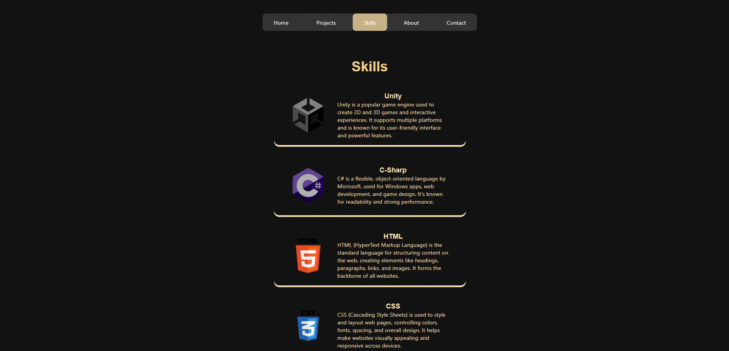

With again a small hover effect.

**Second Lookback at my website:**

Jorrit came to me again and asked for a second review on my website. Even though I did not work a lot on it and hadn’t made much progress on the website because I kept myself busy with the game I was working on we had a talk and I showed him what I did. He was happier that I removed the old projects page but he gave the same feedback he wanted a project page for each of my projects. And my first priority was the website not the game.

Then I started collecting all the images and texts for all the projects that I have worked on. That took way too long but it made my projects page look better a thousand times just by getting better pictures:

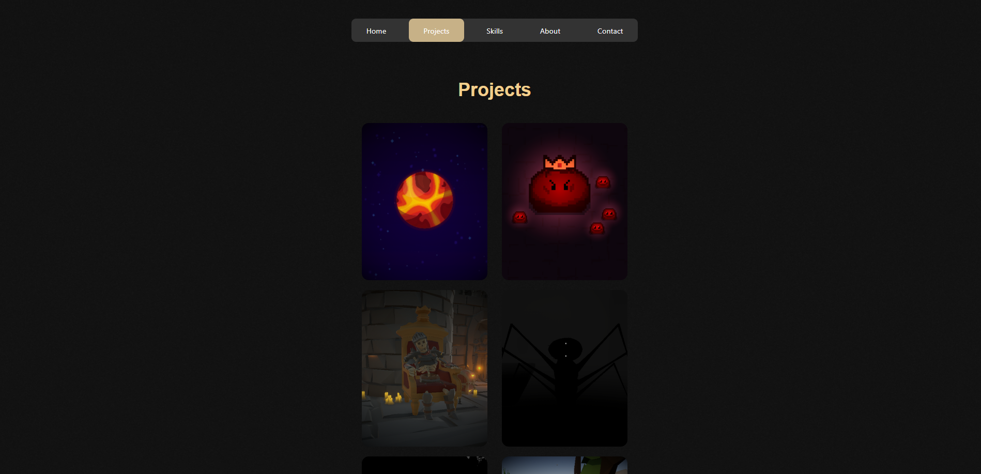

Hover:

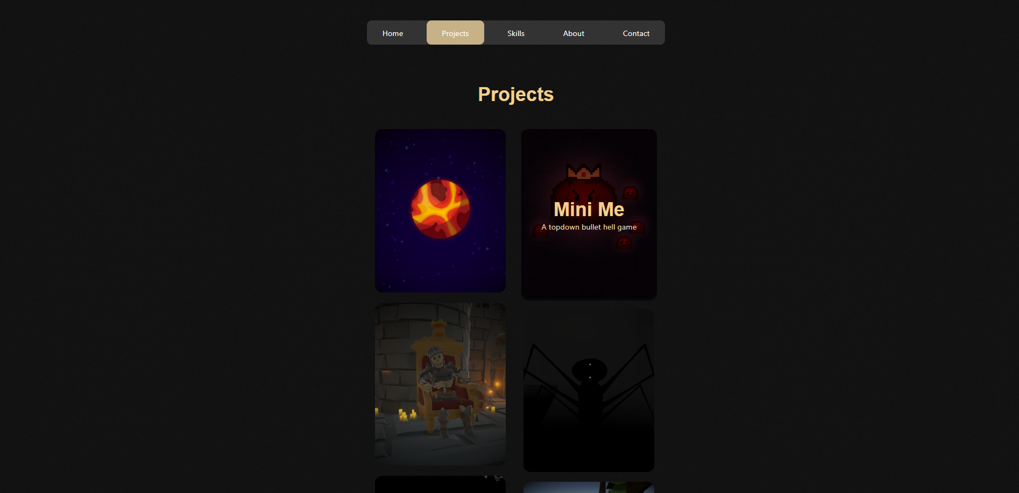

And when you click on the projects you get navigated to the specific projects page containing a thumbnail picture. Most of the times a video (depends if the project is finished). 3 things that I am proud of or things that I have learned from the project. And a summary of my experience on the project and lastly a small photo gallery:

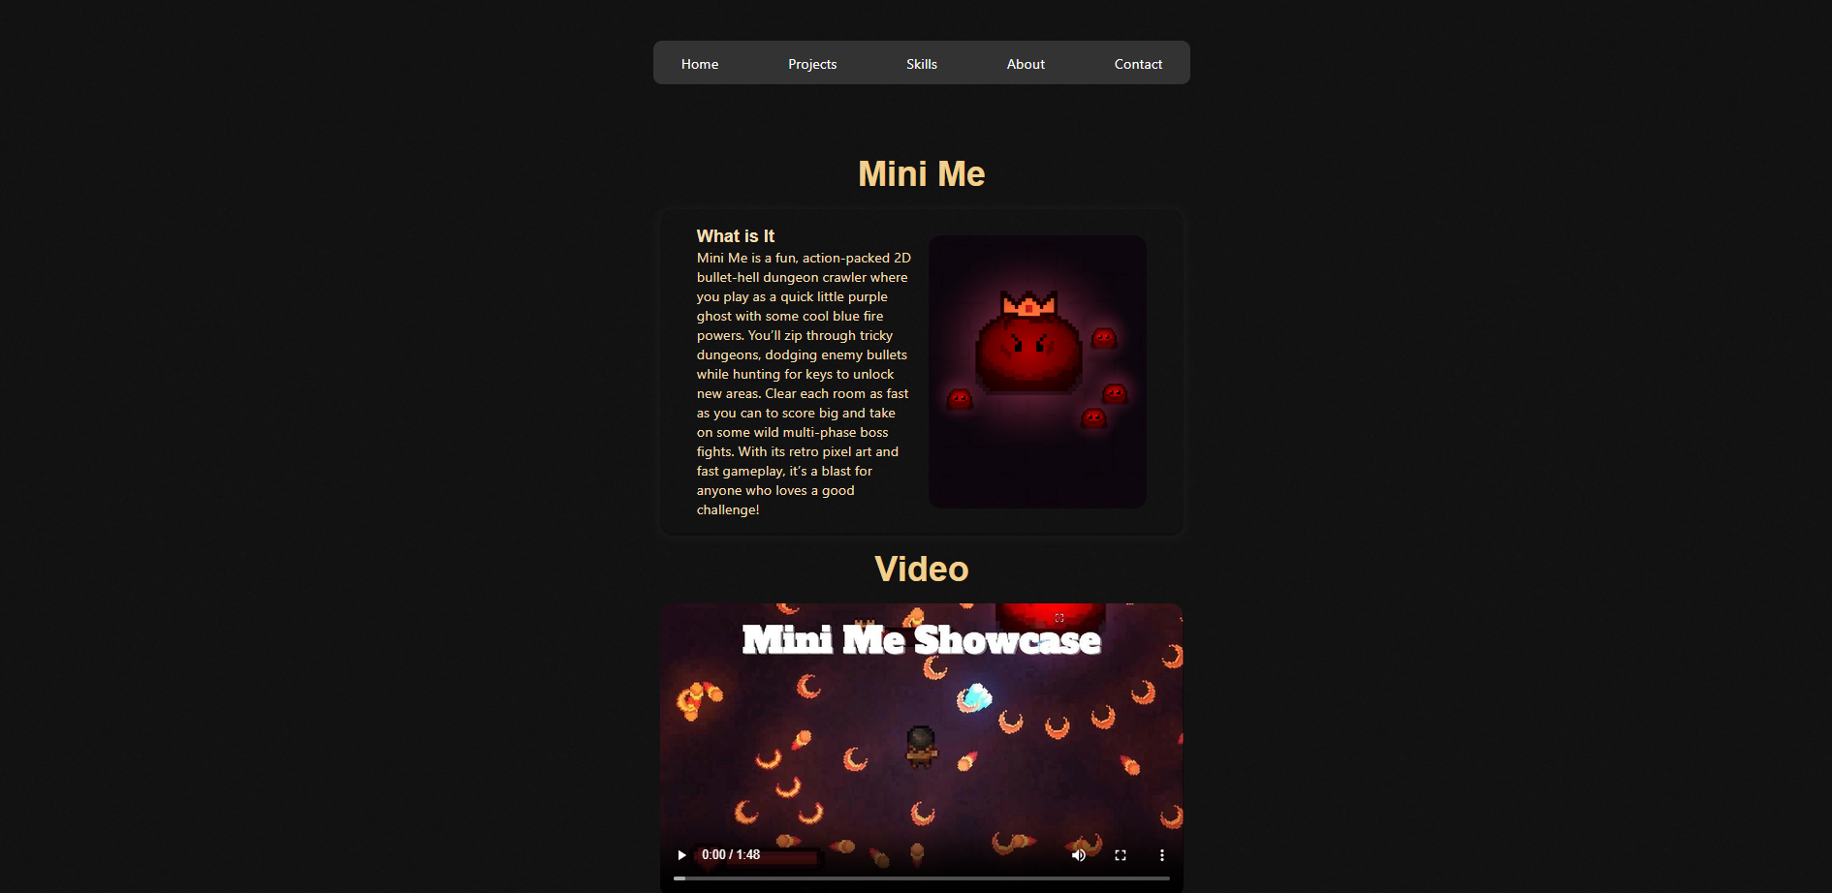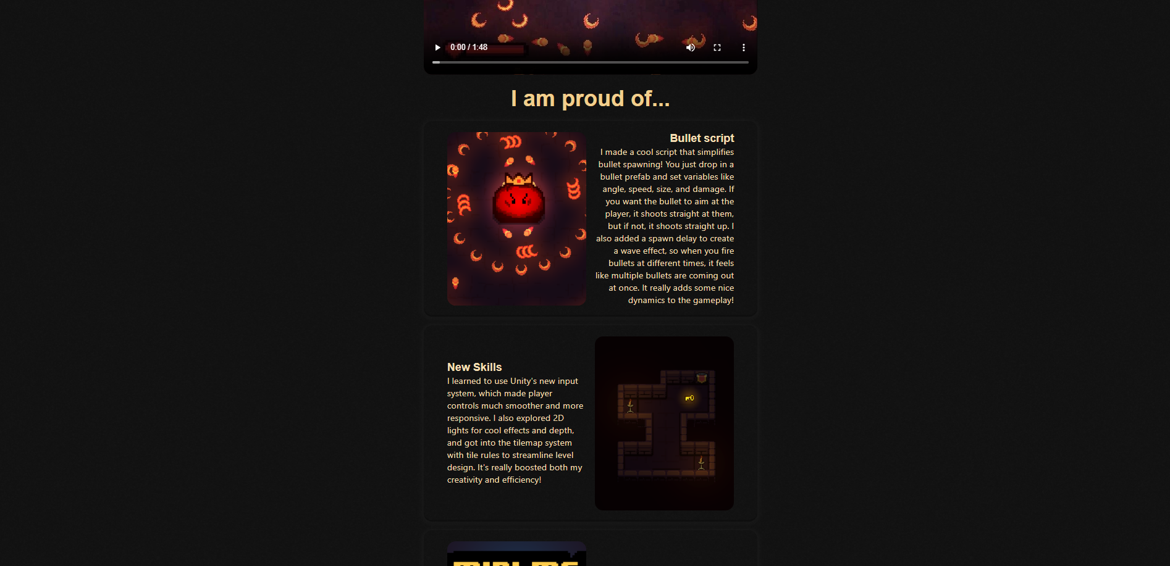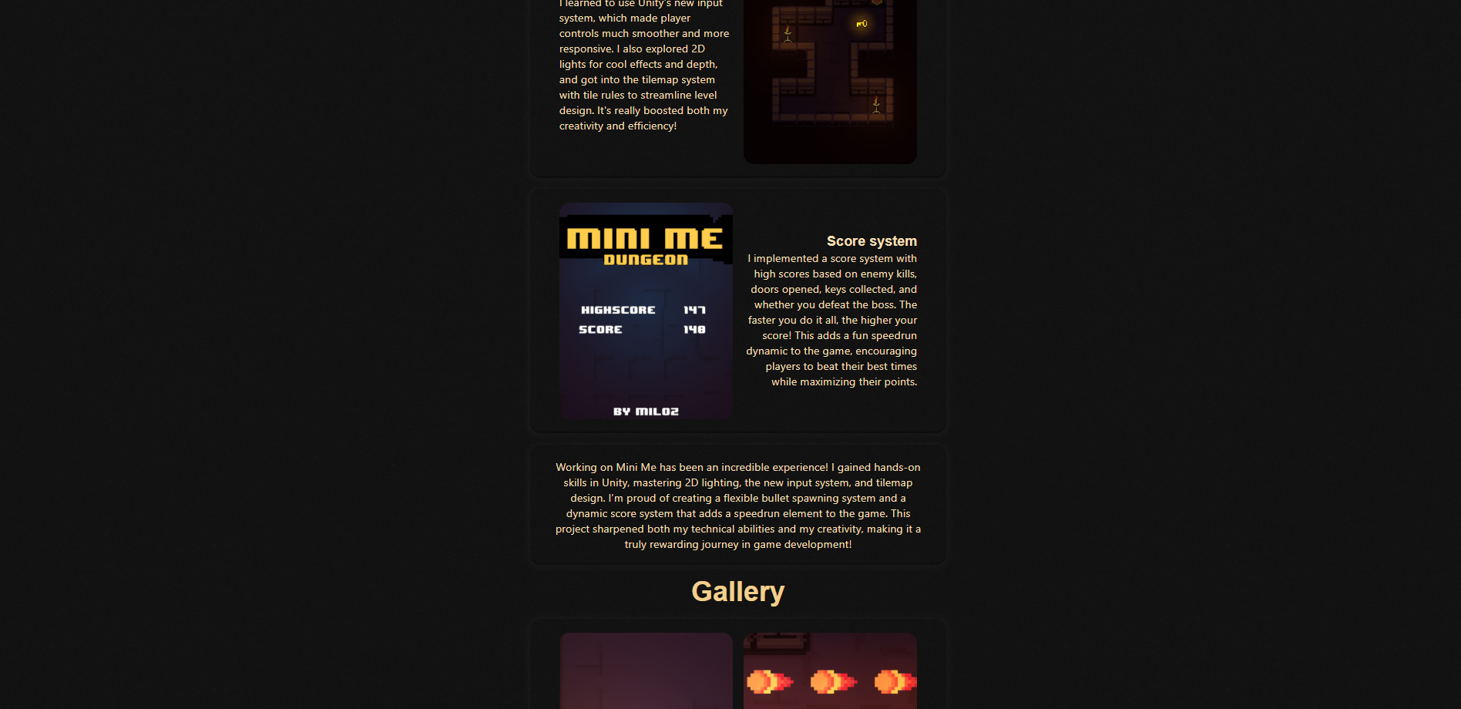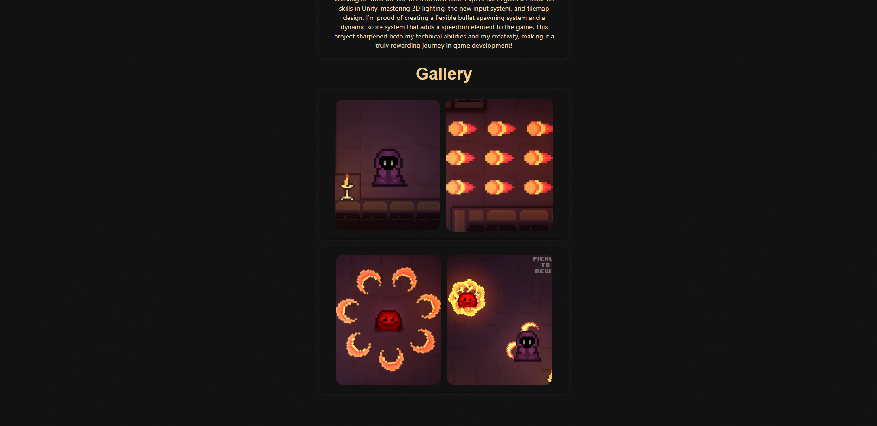

And I filled in all the images and texts for all the projects.

And the last thing I did is adding a link to my linkedin and github (it works):

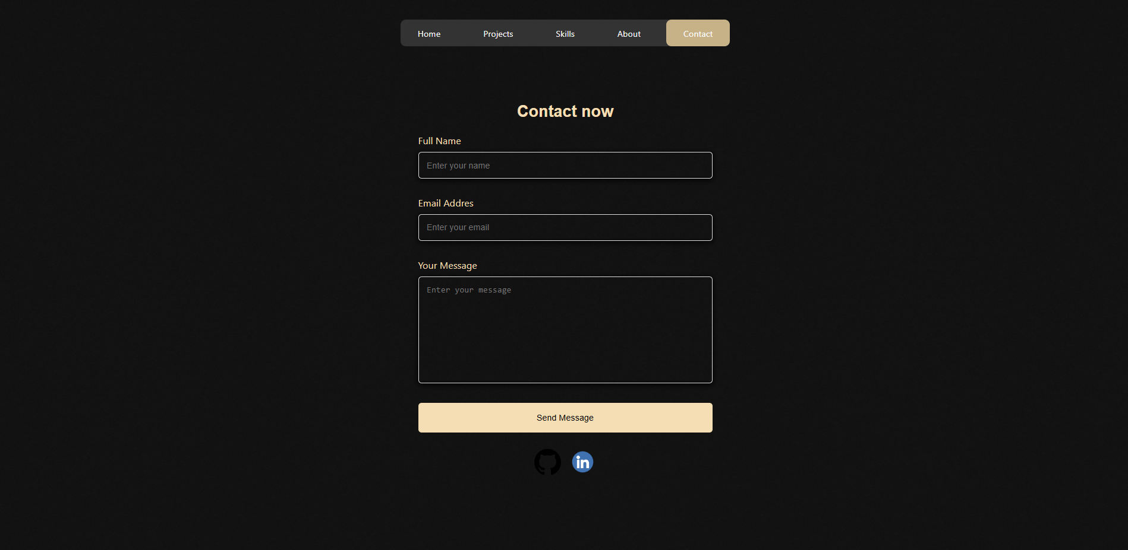

Then I made a screen recording of the website and tried to publish it.

**Publishing**

But I cant publish the website because the repo is owned by SintLucas. I will be running the website when I am done with the assignment and can remove it from the sintlucas repo.

**Scrumboard**

Regarding the scrumboard. I did not use it at all. I used the srumboard in the first 3 days in the making of the website but then forgot all about it. But at the end I sorted it all out. Although I wanted to make the entire website in a week. I thought I had finished it but jorrit wanted something else. So I ended up working on it in another week. But the scrum planning was all over the place.

**Drive Or Die**

I asked Jorrit for another project because I did not like making websites and he told me to make a game for on my portfolio website. So I teamed up with Tim and began creating drive or die.

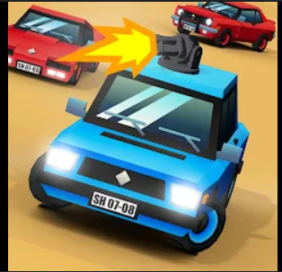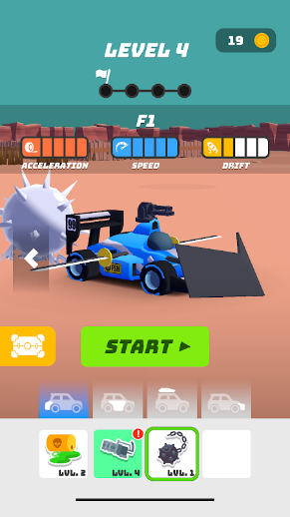

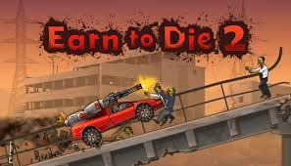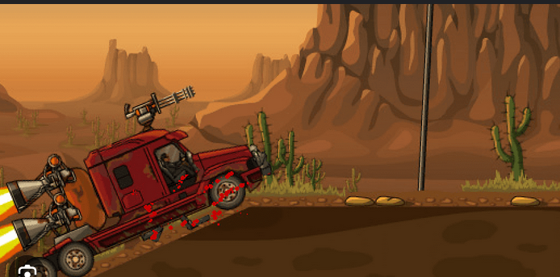

**Concept:**

You drive a car in an isometric view in a procedurally generated map. There are many zombies and obstacles stopping you on your tracks. The further you get the harder it gets for you to make progress because the zombies get bigger and heavier. You have fuel that you use to drive and boost your car. If you have no fuel left your car can’t drive, that means the game is over. But you can refuel on different fuel stations that appear on set distances. You can upgrade your car with turrets and bigger bumpers in the main screen by buying crates of different Tiers in the crate shop.

MOSCOW table

|  |  |  |  |
| --- | --- | --- | --- |
| Must | Should | Could | Wont |
| Car control | Currency | Pause Menu | Free drive map |
| Map | Crates | Settings |  |
| Zombies | Upgradables | Car skins |  |
| Fuel | Menu |  |  |
|  | Adv Obstacles |  |  |
|  | Boost |  |  |
|  | Sounds |  |  |
|  | Assets |  |  |
|  | VFX |  |  |
|  | Lighting |  |  |

**Mechanics:**

* Car (WASD)
* The further you get with the car the more money you will earn
* Need gas to continue driving
* You can find a gas station; this will give you gas, but it is also a mark for the next stage.
* You can boost to get some extra speed
* There are zombies that try to stop you, they have weight. When colliding it will slow you down
* Obstacles where you need to be careful otherwise you crash
* Obstacles with Jumps over stuff
* You can open crates for upgrades, every crate has a tier (1-3) the higher the crate, the more expensive, but better loot.

Week 1:

Tim: Car movement, grip control and Kilometer per hour meter.

Milan: Zombie behaviour, collecting assets and the map.

Working on the zombies was hard because the asset was glitched. I ended up fixing it in the end but it took a while. Then I made the zombie spawn in and walk towards you if you are in range of the zombie. I also made the zombie deal damage if it can hit you but if the car moves fast enough the zombie dies on impact. It all look pretty wack but I ended up fixing it in week 2.

Week 2:

Tim: Added a turret, bumper and car drive shader. Improved grip control. Boost

Milan: Still working on the zombie and map.

I was busy in real life so I couldn’t really work on the game a lot.

Week 3:

Tim: 2 cinematic videos of the car. Added fuel to the car.

Milan: VFX (Improved turret and added to it, Zombie sounds and vfx, Cam effects, post processing) Revamped the entire map and finished it, Finished zombies. Added a score counter.

I learned working with unity’s particle system and post processing. It gave me a lot of knowledge about game polishing and It was very fun to work on.

Week 4:

Tim Main menu, shop

Milan: More Vfx, advanced obstacles, sounds